**Checkered Faux Taxidermy Deer Head with Gold Antlers**

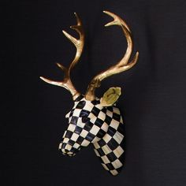The Checkered Faux Taxidermy Deer Head with Gold Antlers is a striking blend of modern design and nature-inspired artistry. This piece features a faux deer head mounted on a checkered-patterned backdrop, creating a bold, graphic contrast. The gold antlers add a touch of elegance and luxury, standing out against the geometric design. Ideal for contemporary spaces, it serves as both a statement piece and a conversation starter, combining the rustic charm of taxidermy with a fresh, artistic twist. Perfect for those who appreciate unique home decor with a touch of whimsy and sophistication.